UNIT 4 CORROSION AND ITS CONTROL
PART-A
1. Define Pilling Bedworth Rule. (Jan 13, Jan 14, Jan 15, May 15)
(a) An oxide layer is porous and non-protective, if volume of metal oxide formed is less than volume of metal from which it is formed. V_{MO} ≤ V_{M}
E.g. Alkali metals like Li, Na and K and alkaline earth metals like Ca, Mg and Sr form oxides of volume less than the volume of metals.
(b) An oxide layer is non-porous and protective, if volume of metal oxide formed is at least as great as volume of metal from which it is formed. V_{MO} ≥ V_{M}
E.g. Metals Al, Sn, Pb and Cu form oxides whose volume is greater than volume of metal.
2. Differentiate between Chemical and Electrochemical corrosion. (Sep 20)
Dry (or) Chemical corrosion | Wet (or) Electrochemical corrosion
(i) Occurs in dry state.  (ii) Involves direct chemical attack of metal by the environment.  (iii) Corrosion products accumulate in same spot where corrosion occurs.  (iv) E.g. Formation of scale on iron. | Occurs in presence of moisture or electrolyte.  Involves setting up of a huge number of tiny galvanic cells.  Corrosion occurs at anode while products gather at cathode, hence it is not self stifling.  E.g. Rusting of iron in moist atmosphere.
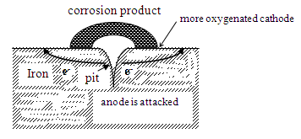
3. Write short note on pitting corrosion. (Dec 19)
kb ju+7g6corrosion is a localized attack, resulting in formation of pit or cavity, it is called as Pitting corrosion. Around the pit or cavity, the metal is relatively unattacked. Thus, pitting corrosion results in the formation of pinholes, pits and cavities in the metal.
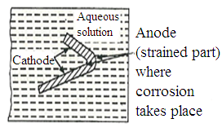
4. Write short note on Stress corrosion? (Dec 19)
Stress corrosion or stress cracking is the combined effect of static tensile stress and corrosive environment on a metal. It is characterized by a highly localized attack.
E.g. Corrosive agents are highly specific and selective such as caustic alkalis and strong nitrate solution for mild steel.

5. How the corrosion is controlled by cathodic protection? (Dec 19)
The process of reduction or protection of parent metal from corrosion by forcing base metal to behave as cathode is known as cathodic protection.
There are two types of cathodic protection.
(a) Sacrificial anodic protection method
(b) Impressed current cathodic protection method
6. What is differential aeration? Why differential aeration corrosion is called as concentration cell corrosion. (May 11, Jan 15)
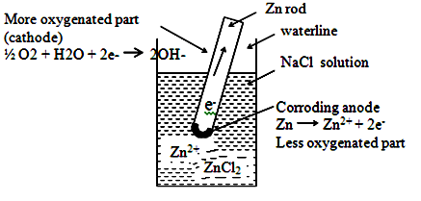
Concentration cell corrosion occurs when metal surface is exposed to conducting medium with different concentration.
When metals are exposed to varying concentration of oxygen, it is called Differential Aeration corrosion.
E.g. Iron rod half immersed vertically in water starts to corrode at bottom
7. Explain corrosion inhibitors with examples. (Sep 20)
Inhibitors are organic or inorganic chemical substances when added in small quantity to corrosive environment effectively decreases the corrosion rate by forming a protective layer either at anodic or cathodic area.
(a) Anodic inhibitors: Anodic Inhibitors are generally salts which contain anions that form sparingly soluble compounds with ions of the metal.
Eg. Compounds of transition elements with a high content of oxygen such as chromates, phosphates, tungstates, etc.
(b) Cathodic inhibitors: Cathodic inhibitors are substances capable of reacting with cathode to form precipitates. Action of any inhibitors depends on the particular metal and environment.
8. What are protective coatings? What are its types? (Dec 18)
Protective coatings functions as a continuous physical barrier between coated surface and environment. Besides corrosion protection, they give wear resistance, hardness, electrical and thermal insulation properties.
Protective coatings are mainly classified as, (i) Metallic coatings,
(ii) Chemical conversion coatings and (iii) Organic coatings
9. What is the use of palm oil in Tinning process? (Jan 14)
Palm oil protects the hot tin-coated surface from immediate oxidation.

10. Briefly explain about metal cladding. (Nov 10, Dec 19)
Metal cladding is the process by which a dense layer of coating metal is bonded or sandwiched between two layers of coat metal and pressed between rollers. Choice of cladding material depends on the corrosion-resistance required for particular environment.
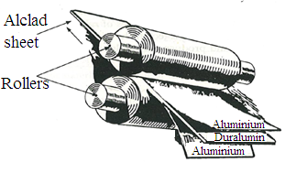
Corrosion-resisting metals like nickel, copper, lead, silver, platinum, etc., and their alloys and stainless steel can be used as cladding material. The base metals are mild steel, aluminium, copper, nickel and their alloys.
Application
Wide use is made in aircraft industry as alclad sheeting, in which plate of duralumin is sandwiched between two layers of 99.5% pure aluminium.
11. Distinguish between Galvanizing and Tinning. (May 14)
Galvanizing | Tinning
(i) Process of covering iron or steel with a thin coat of Zinc metal.  (ii) Zinc protects base metal sacrificially.  (iii) Galvanized containers cannot be used for storing acidic foodstuffs, since it forms poisonous compounds. | Process of covering steel with a thin coat of Tin metal.  Protects metal by noble character and higher corrosion resistance.  Tin coated containers can be used for storing any foodstuff, since tin with acid is non toxic.
12. Write short note on anodizing. (May 14)
Oxidation of metal surfaces by electrolysis process is called anodizing. These coatings are produced on non-ferrous metals like aluminium, magnesium, zinc and their alloy by anodic oxidation process in which the base metal acts as anode.
13. Why anodizing best suited for Aluminium? (Jan 14)
Aluminium form non-porous, tight, oxide film (Al₂O₃) which stops further corrosion.
14. Why impure metal corrodes faster than pure metal on identical conditions? (May 15 May 19)
Impurities in a metal cause heterogeneity and form minute electrochemical cells at exposed parts; thereby anodic parts get corroded.
15. Corrosion occurs in steel pipe connected to copper plumbing. Explain. (Nov 11, May 13, Jan 15)
When iron or steel pipe connected to copper plumbing is exposed to an electrolyte, then iron (metal higher in electrochemical series) undergoes corrosion, since iron forms anode and is attacked and corroded. Whereas copper (metal lower in electrochemical series) acting as cathode is protected. This type of corrosion is called galvanic corrosion.
16. Why wire mesh corrodes faster at the joints? (Dec 18)
Joints of wire mesh are stressed due to welding, so this becomes anodic with respect to unjoined wires.
At these anodic parts, oxidation takes place and the metal is corroded fast; while cathodic parts remain unaffected.
17. Pure metal rod half-immersed vertically in water or buried under the soil starts corroding at the bottom. Why? (Jan 15)
This is due to the differential aeration corrosion. The rod above and closely adjacent to waterline/soil is more strongly aerated and becomes cathodic; while the lower part of rod immersed in water/soil is less oxygenated and become anodic. So a difference of potential is created and electrochemical corrosion takes place. This causes corrosion of anodic part and metal rod starts corroding at the bottom.
18. Zinc is more corroded, when coupled with copper than with lead. Why? (May 14)
Standard reduction potential values of given metals are,
Zn = – 0.76 V Pb = – 0.13 V Cu = + 0.34 V
The difference between zinc and copper is more when compared to lead. Hence zinc is more readily corroded, when coupled with copper than with lead.
19. Distinguish between electroplating and anodizing. (Jan 13)
Electroplating | Anodizing
(i) Electrolytic process  (ii) Metal is made as cathode  (iii) Occurs at cathode and layer is not porous  (iv) The coating layer is a metal  (v) All metals can be used as substrate  (vi) E.g. Copper plating over iron. | Electrical process  Metal is made as anode  Occurs at anode and the layer is porous  The coating layer is an oxide  Only easily oxidation metals such as aluminium can be used  E.g. Oxide coating over aluminium.

PART - B
- Explain the various factors influencing corrosion. (Jan 13, May 14, Jan 15, May 15, Jan 16, May 16, Nov 16,May 19,Dec 19),)
(a) Nature of metal
(i) Position in Galvanic Series: Rate and severity of corrosion, depends upon the difference in their positions. Greater the difference, faster is the corrosion of anodic metal/alloy.
(ii) Overvoltage: Reduction in overvoltage of metal/alloy accelerates the corrosion rate.
(iii) Relative areas of anodic and cathodic parts: When two dissimilar metals or alloys are in contact, corrosion of anodic part is directly proportional to the ratio of areas of cathodic part and anodic part. Corrosion is more rapid and severe and highly localized, if the anodic area is small.
(iv) Purity of metal: Impurities in metal cause ‘heterogeneity’, and form minute/tiny electrochemical cells (at exposed parts), and anodic parts get corroded. The rate and extent of corrosion increases with increasing exposure and extent of impurities. Consequently, corrosion resistance of a metal may be improved by increasing its purity.
(v) Volatility of corrosion products: If the corrosion product is volatile, it volatilizes as soon as it is formed, there by leaving the underlying metal surface exposed for further attack. This causes rapid and continuous corrosion, leading to excessive corrosion. E.g. Corrosion product of Molybdenum in Molybdenum oxide is volatile.
(vi) Nature of surface film: Ratio of volume of metal oxide to metal is known as “specific volume ratio”. Greater the specific volume ratio, lesser is the oxidation corrosion rate.
(vii) Passive character of metal: Metal like Tl, Al, Cr, Mg, Ni and Co are passive and exhibit higher corrosion resistance than expected from their positions in galvanic series.

(b) Nature of corroding environment
(i) Temperature: With increase in temperature of environment, reaction as well as diffusion rate increases, thereby corrosion rate is generally enhanced.
(ii) Humidity: Humidity of air is the deciding factor in atmospheric corrosion. Critical humidity is defined as the relative humidity above which the atmospheric corrosion rate of metal increases sharply.
(iii) Presence of impurities in atmosphere: Atmosphere, in vicinity of industrial areas contains corrosive gases like CO₂, H₂S, SO₂ and fumes of HCl, H₂SO₄. In presence of these gases, acidity of liquids adjacent to metal surfaces increases and its electrical conductivity also increases. This results in an increase of corrosion current flowing in local electrochemical cell on the exposed metal surfaces.
(iv) Influence of pH: Generally acidic media are more corrosive than alkaline and neutral media. Consequently corrosion of metals, readily attacked by acids, can be reduced by increasing the pH of attacking environment. E.g. Zn, which rapidly corroded, even in weakly acidic solution such as carbonic acid suffers minimum corrosion at pH 11.
(v) Formation of oxygen concentrated cell: With increase in supply of oxygen/air to moist-metal surface, the corrosion is promoted. Less oxygen concentration parts become anodic, while more oxygenated regions becomes cathodic there by leading to the formation of oxygen concentration cell in which anodic part suffers corrosion.
(vi) Polarization of electrode: Potential difference between anode and cathode is the driving force of an electrochemical corrosion process, but the corrosion rate is controlled by current flowing in circuit. The extent of corrosion can be reduced by adding certain organic or inorganic substances called corrosion inhibitors. Inhibitors added to corrosive environment lower the corrosion rate by retarding anodic or cathodic reactions or both.

2. Explain the mechanism involved in Oxidation corrosion. (Jan 15, May 16)
Corrosion: Any process of destruction and consequent loss of solid metallic material through an unwanted chemical or electrochemical attack by its environment starting at its surface is called corrosion.
Oxidation corrosion or Corrosion by Oxygen
Oxidation corrosion is caused by direct action of oxygen on metals at low or high temperatures in absence of moisture. Oxygen present in atmosphere attack metal surfaces resulting in formation of metallic oxide which is the corrosion product.
Alkali metals like Li, Na, K and alkaline earth metals like Be, Ca and Sr are oxidized at low temperature. At high temperature, almost all metals undergo oxidation corrosion except noble metals like Ag, Au and Pt.
Mechanism
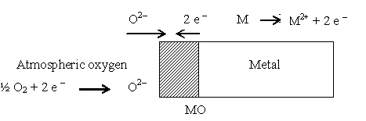
When a clean metal surface is exposed to oxygen, it gets absorbed on the metal surface at ordinary temperature. But at high temperature, oxidation of metal occurs. Oxidation occurs first at metal surface resulting in the formation of metal ions (M^{n+}) and oxygen changes to ionic form (O^{2–}) and both ions react to form metallic oxide. This corrosion product will present as oxide layer or scale over metal surface.

Reactions in oxidation corrosion are,
Oxidation: M M²⁺ + 2 e –
Reduction: ½ O₂ + 2 e – O ^{2–}
Net reaction: M + ½ O₂ M²⁺ + O^{2–} (metal oxide)
This resulting metal oxide scale forms a barrier, which tends to restrict further oxidation. For further oxidation to continue either metal ions must diffuse outwards through scale to the surface or oxide ions must diffuse inwards through scale to the underlying metal.
Usually both types of transfer are noticed. Since the metal ion is smaller than the oxide ion, outward diffusion of metal is generally much more than the inward diffusion of oxygen.
Most of the oxygen rich compound is found at scale-gas interface and most of the metal-rich compounds are found at metal-scale interface. Extent of corrosion depends on the nature of oxide layer formed and it plays a major role in oxidation corrosion.
porous and non-porous layer.
When oxidation starts, a thin layer of oxide is formed on metal surface and the nature of this film decides further corrosion. Depending upon the oxide layer, following cases arises:
(i) Porous and non-porous layer
If the surface having pores or cracks on oxide layer, atmospheric oxygen has access to the underlying surface of metal, through pores or cracks of layer. Thus the corrosion continues unobstructed, till the entire metal is completely converted into its oxide.
Pilling Bedworth Rule
(a) An oxide layer is porous and non-protective, if the volume of metal oxide formed is less than the volume of metal from which it is formed.
V_{MO} ≤ V_{M}
E.g. Alkali metals like Li, Na, K and alkaline earth metals like Ca, Mg and Sr form oxides of volume less than volume of metals. Consequently, the oxide layer develops cracks and pores and permits free access of oxygen to the underlying metal surface. Thus, corrosion continuous non-stopping.
(b) An oxide layer is non-porous and protective, if volume of metal oxide formed is at least as great as volume of metal from which it is formed.
V_{MO} ≥ V_{M}
E.g. Metals Al, Sn, Pb and Cu forms oxides whose volume is greater than volume of metal.
Thus an extremely tight adhering non-porous layer is formed. Due to the absence of any pores or cracks in the oxide film, rate of oxidation rapidly decreases.
(ii) Stable oxide layer
The oxide layer formed in some cases is fine-grained in structure and can get adhered strongly to the parent metal surface. Such layers naturally do not allow penetration of oxygen to the underlying metal surface and thus acts as protective film.
E.g. Oxide films on Al, Sn, Pb and Cu are stable, tightly adhering and impervious in nature. Thus further oxidation is prevented.
(iii) Unstable oxide layer
In some metals, the oxide layer formed is unstable and decomposes back into metal and oxygen. Metal oxide Metal + Oxygen
In this the forward reaction is more favourable. Therefore, oxidation corrosion is not possible in these kinds of metals.
E.g. In noble metals, metallic or elemental state is naturally more stable than their oxide or combined state.
Thus unstable oxide layers are mainly produced on the surface of noble metals such as Ag, Au and Pt and they do not undergo oxidation corrosion.
(iv) Volatile oxide layer
In some metals, the oxide layer formed is volatile in nature. Thus the oxide layer volatilizes as soon as it is formed, thereby leaving the underlying metal surface exposed for further attack. This causes rapid and continuous corrosion on the metal and leads to excessive corrosion.
E.g. Molybdenum oxide (MoO₃) is volatile in nature.
3. Explain mechanism in Wet or electrochemical corrosion.
(May 12, May 13, Jan 14, May 14, Jan 15, May 15, May 16, May 17,Dec 18, Dec 19,Sep20)
Corrosion: Any process of destruction and consequent loss of solid metallic materials through an unwanted chemical or electrochemical attack by its environment starting at its surface is called corrosion.
Wet corrosion occurs in presence of a conducting medium. This type of corrosion occurs under the following conditions:
(i) when a metal is in contact with a conducting liquid.
(ii) when two dissimilar metals are in contact with each other in presence of aqueous
solution or moisture.
(iii) when metal is exposed to an electrolyte with different concentration of oxygen.
Wet corrosion is more frequently encountered than dry corrosion. This corrosion occurs due to the existence of separate anodic and cathodic parts between which the current flows through the conducting solution.
Mechanism
Wet corrosion involves flow of electron current between anodic and cathodic areas.
Reaction at anode
At anodic area, oxidation reaction takes place, thereby dissolution of metallic ions with the release of free electrons take place. Thus, corrosion always occurs at anodic areas.
M M^{n+} + n e –
dissolve in solution
M^{n+}
forms compounds
Reaction at cathode
At cathode area, reduction reaction takes place and usually do not affect cathode, since most metals cannot be further reduced. So at cathode, dissolved constituents in conducting medium accept the electrons to form ions like OH–, O^{2–}, etc. Thus the metallic ions at anode and non metallic ions at cathode diffuse towards each other through conducting medium and form a corrosion product somewhere between anode and cathode.
Depending on the nature of corrosive environment, cathode reactions are,
- Evolution of Hydrogen, (b)Absorption of Oxygen, (c) Metal deposition
Of these, the first two are more probable.
(a) Hydrogen evolution
This corrosion takes place when base metal is in contact with acidic solution. For example, corrosion of iron in industrial water containing HCl undergoes this corrosion.
In Fe metal, anodic reaction is dissolution of iron as ferrous with liberation of electrons.
Fe Fe²⁺ + 2 e – (oxidation)
These electrons flow through the metal from anode to cathode. At cathode H⁺ ions of acidic solution take up these electrons and liberate hydrogen gas.
2 H ⁺ + 2 e – H₂ (reduction)
Overall reaction is, Fe + 2 H⁺ Fe ²⁺ + H₂
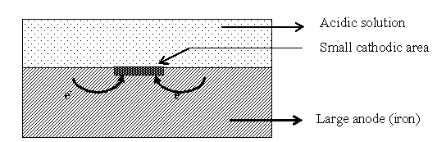
Thus, this type of corrosion causes displacement of hydrogen ions from acidic solution by metal ions. Consequently, all metals above hydrogen in electrochemical series have a tendency to get dissolved in acidic solution with simultaneous evolution of hydrogen.
Usually in hydrogen evolution type of corrosion, anodes are very large areas and cathodes are small areas.
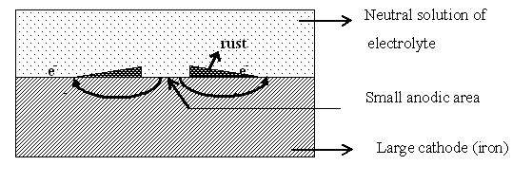
(b) Oxygen absorption
This type of corrosion takes place when base metal is in contact with neutral solution of electrolytes in presence of atmospheric oxygen.
Rusting of iron in neutral aqueous solution of NaCl electrolyte in presence of atmospheric oxygen is an example of this type of corrosion.
The surface of iron is usually coated with a thin film of iron oxide. If this iron oxide film develops cracks or pores, a tiny electrochemical cell is formed if the metal is immersed in a conducting medium containing sufficient dissolved oxygen. Here, well coated part acts as cathode and the pores or cracks acts as anode.
At anodic areas, iron dissolves as ferrous ions with liberation of electrons.
Fe Fe²⁺ + 2 e – (oxidation)
The liberated electrons flow from anodic to cathodic areas through iron metal, where the electrons are intercepted by the dissolved oxygen in water.
½ O₂ + H₂O + 2 e – 2 OH – (reduction)
Fe²⁺ ions at anode and OH– ions at cathode diffuse and when they meet, ferrous hydroxide is precipitated.
Fe²⁺ + 2 OH – Fe(OH)₂
(i) if enough oxygen is present, ferrous hydroxide is easily oxidized to ferric hydroxide.
4 Fe (OH)₂ + O₂ + 2 H₂O 4 Fe (OH)₃
On partial dehydration, 2 Fe(OH)₃ Fe₂O₃.H₂O + 2 H₂O
This product Fe₂O₃.H₂O, is called yellow rust.
(ii) if the supply of oxygen is limited, the corrosion product may be black anhydrous magnetite, Fe₃O₄.
Generally, in this type of corrosion cathode posses large area and anode areas are small. As ionic diffusion through conducting medium is more for small sized Fe²⁺ than larger OH– ions, rust formation is noticed usually near cathode. So corrosion occurs at anode, but rust is deposited near cathode.
(c) Metal deposition
Metal ion reduction and metal deposition occur only in special environments such as in chemical plants.
4. Write the differences between Chemical and Electrochemical corrosion. (Jan 14 May 19, Dec 19)
Dry (or) Chemical corrosion | Wet (or) Electrochemical corrosion
(i) Occurs in dry state.  (ii) Involves direct chemical attack of metal by environment.  (iii) Follows adsorption mechanism.  (iv) Even a homogeneous metal surface will be corroded.  (v) Corrosion products accumulate in same spot where corrosion occurs and hence it is self-stifling.  (vi) Uniform corrosion is the rule.  (vii) E.g. Formation of scale on iron, reaction of dry HCl gas on iron and tarnishing of Ag in H₂S. | Occurs in moisture or electrolyte.  Involves setting up of a huge number of tiny galvanic cells.  Follows electrochemical reactions.  Surface heterogeneity or bimetallic contact is an important condition.  Corrosion occurs at anode while products gather at cathode and hence it is not self stifling.  Pitting is frequent, when anode is small.  E.g. Rusting of iron in moist air, de-zincification of brass, stress corrosion and cracking of iron.

5. Explain galvanic corrosion with example. (Nov 10, May 11, Nov 11, Jan 14, Jan 15, Sep 20)
When two dissimilar metals (e.g., zinc and copper electrodes) are electrically connected and immersed in an electrolyte solution, produce a potential difference. Here, zinc metal forms anode because of higher in electrochemical series and undergoes oxidation i.e. Zn²⁺ gets dissolved from Zn metal surface and thereby corrosion occurs. On the other hand, copper metal acts cathode (lower in series) and remains unaffected. This type of corrosion is called galvanic corrosion.
Mechanism
In acidic solution, the corrosion occurs by hydrogen evolution process, while in neutral or slightly alkaline solution, oxygen absorption occurs. The electronic current flows from anode metal (zinc) to cathode metal (copper).
Zn Zn²⁺ + 2 e – (oxidation)
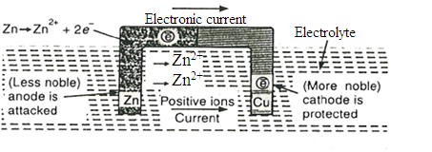
Thus, it is evident that the corrosion occurs at anode metal; while the cathodic part is protected from the attack.
Extent of corrosion depends on the difference in position of these two metals in electrochemical series. Larger the difference in their position, greater will be the extent of corrosion. Extent of galvanic corrosion also depends on the area of anode and cathode. The rate of corrosion will be high if area of cathode is large and anode is small, because larger cathode demands more electrons, and therefore faster the corrosion occurs.
E.g. (i) Steel screws in brass marine hardware (ii) Lead-antimony solder around copper wire
(iii) A steel propeller shaft in bronze bearing (iv) Steel pipe connected to copper plumbing.
6. Write note on pitting corrosion. (Jan 13, Jan 14, May 14, May 15)

Pitting corrosion is a localized accelerated attack, resulting in the formation of pit or cavities around which the metal is relatively un-attacked. Thus, pitting corrosion results in the formation of pinholes, pits and cavities in the metal. Pitting is usually the result of breakdown or cracking of protective film on a metal at specific points. This gives the formation of small anodic and large cathodic areas. Breakdown of protective film may be by,
(i) Surface roughness or non-uniform finish and scratches or cut edges
(ii) Local strain of metal due to non-uniform stress & sliding under load
(iii) Turbulent flow of solution over metal surface and by chemical attack.
Metals having passive character show a marked pitting under all conditions, which leads to the destruction of their passivity. For example, stainless steel and aluminium show pitting in chloride solution.
Presence of impurities like sand, dust and scale embedded on the surfaces of metal also lead to pitting. Because of different amount of oxygen in contact with metal, small part which is underneath the impurity becomes anodic areas and the surrounding large parts become cathodic areas and intense corrosion starts below the impurity. Once a small pit is formed, the rate of corrosion will be increased.

7. Explain the concentration cell corrosion. (May 10, Nov 11, Jan 14)
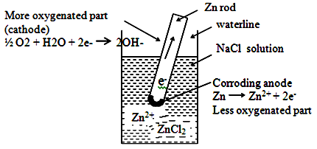
Concentration cell corrosion occurs when metal surface is exposed to an electrolyte medium of varying concentration or aeration. This may be the result of local difference in metal-ion concentrations, caused by local temperature differences or inadequate agitation or slow diffusion of metal-ions produced by corrosion.
Differential aeration corrosion occurs when one part of metal is exposed to different air concentration from other part; as a result a potential difference between differently aerated areas is created. It has been experimentally found that poor-oxygenated parts are anodic.
Thus differential aeration of metal causes a flow of current, called differential current. It is the most common type of electrochemical corrosion that takes place in metals partly dipped in solutions and metals partly covered with dust, sand, etc.
Consider a metal like zinc partly immersed in a dilute solution of NaCl. Metal portion above the liquid surface is exposed to higher concentration of oxygen in the atmosphere and the metal portion just below the liquid portion has less access to oxygen. A concentration cell is set up and the more oxygenated part acts as a cathode while less oxygenated part acts as anode. So a difference of potential is created, which causes a flow of current between two differentially aerated areas of the same metal.
Zn Zn²⁺ + 2 e – (anode)
½ O₂ + H₂O + 2 e – 2 OH – (cathode)
The circuit is completed by migration of ions through the electrolyte and flow of electrons through the metal from anode to cathode takes place.
Hence corrosion will take place at anodic area and oxygen will take up electrons at cathodic area to form hydroxyl ions. Thus, portion under water surface undergoes corrosion.
Some other examples of differential corrosion are,
- Iron corrodes under drops of water or salt solution.
- Corrosion in steel water tanks in crevices and cracks.
- Corrosion of metal under accumulated area of dirt, sand, scale or other
contaminations.
- Metals exposed to aqueous media corrode under block of wood or piece of glass
which screen that portion of metal from oxygen access.
8. Write a brief note on stress corrosion. (Jan 14, May 15, May 19)
Stress corrosion or stress cracking is the combined effect of static tensile stresses and the corrosive environment on a metal. It is characterized by a highly localized attack occurring, when overall corrosion is negligible.
For stress corrosion to occur, presence of tensile stress and a specific corrosive environment are necessary.
The corrosive agents are highly specific and selective such as, caustic alkalis and strong nitrate solution for mild steel, traces of ammonia for mild steel and acid chloride solution for stainless steel
This type of corrosion is observed in fabricated articles of certain alloys (like high-zinc brasses and nickel brasses) due to the presence of stresses caused by heavy working like rolling, drawing, insufficient annealing. However pure metals are immune to stress corrosion.
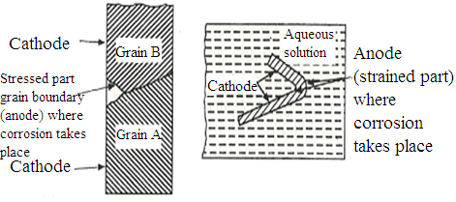
Stress corrosion involves in a localized electrochemical corrosion, occurring along narrow paths, forming anodic areas with respect to more cathodic areas at the metal surface. Presence of stress produces strain, which result in localized zones of higher electrode potentials. These become so chemically active that they are attacked, even by a mild corrosive environment resulting in the formation of a crack. This crack grows and propagates in a plant (perpendicular to the operating tensile stress) until failure occurs or it may stop, after progressing a finite distance.
Some examples of stress corrosions
Season cracking: It is a term applied to stress corrosion of copper alloys, mainly brass. Pure copper is immune to stress corrosion, but presence of some alloying elements like P, As, Al and Si result in marked sensitivity.
Caustic embrittlement: It is very dangerous form of stress corrosion, occurring in mild steels exposed to alkaline solutions at high temperature and stresses. The failure is often associated with steam boilers and heat transfer equipments in which water of high alkalinity attacks mild steel plates, particularly at the crevices near rivets.
9. Explain corrosion control by cathodic protection. (Jan 14, Jan 15, May 15, Nov 16, May 17, Dec 19)
Process of reduction or protection of parent metal from corrosion by forcing base metal to behave as cathode is known as cathodic protection.
There are two types of cathodic protection:
(a) Sacrificial anodic protection method
(b) Impressed current cathodic protection method
(a) Sacrificial anodic protection method (galvanic method)
(Jan 11, May 11, Nov 11, May 12, May 13, Jan 14, Jan 16, May 16)
In this method, the metallic structure to be protected is connected by a wire to a more anodic metal. As a result, all the corrosion is concentrated at this more active metal. The original structure becomes cathode and hence protected from corrosion.
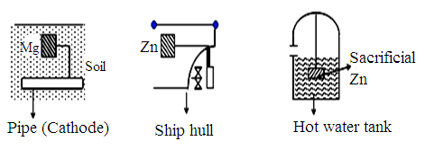
More active metal used for this purpose is called sacrificial anode. When sacrificial anode is corroded, it is replaced by fresh one. Metals employed as sacrificial anodes are Mg, Zn and their alloys.
Applications
Protection of buried pipelines, underground cables, marine structure, ship-hulls, water-tanks, piers, etc.
(b) Impressed current cathodic protection. (Jan 11, May 12, May 13)
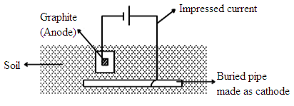
In this, an impressed current is applied in opposite direction to nullify corrosion current and convert corroding metal from anode to cathode.
In electrochemical corrosion, current flows between anodic and cathodic areas and corrosion occurs at anode. By passing external current opposite to the corrosion current, the metal structure is forced to become cathode and thus it does not get corroded.
Usually, impressed current is derived from a direct current source like battery or rectifier on a.c. line. The anode is an insoluble metal like graphite or Pt, buried in the soil or immersed in the corroding medium and connected to the metallic structure to be protected.
The anode is in a backfill, composed of coke breeze or gypsum so as to increase the electrical contact with the surrounding soil.
Applications
This method is mainly applied for large structures of long term operations like open water-box coolers, water-tanks, buried oil or water pipes, condensers, transmission line towers, marine piers, laid-up ships, etc.
10. What are corrosion inhibitors? How do they act? (Jan 11, Jan 14, May 14, May 17)
Inhibitors are organic or inorganic chemical substances when added in small quantity to corrosive environment effectively decreases the corrosion rate by forming a protective layer either at anodic or cathodic area.
Inhibitors are generally classified according to electrode at which the action is taking place and classified as anodic and cathodic inhibitors.
(a) Anodic inhibitors
Anodic Inhibitors are generally the salts which contain anions that form sparingly soluble compounds with ions of the metal.
E.g. Compounds of transition elements with a high content of oxygen such as chromates, phosphates, tungstates, etc.
These substances stifle the corrosion reaction occurring at anode, by forming a sparingly soluble compound with a newly produced metal ion. They are adsorbed on the metal surface forming a protective film or barrier, thereby reducing the corrosion rate.
Although this type of control is effective, yet it may be dangerous. When certain areas are left unprotected by depletion of inhibitor, then severe local attack can occur.
(b) Cathodic inhibitors
Cathodic inhibitors are substances capable of reacting with cathode to form precipitates and its action depends on nature of metal & environment.
(i) In acidic solution
The main cathodic reaction in acidic solution is evolution of hydrogen,
2 H⁺ (aq) + 2 e – H₂ (g)
Corrosion at cathode can be reduced by following methods:
(a) Slowing down the diffusion of H⁺ ions to the cathode: The diffusion of H⁺ ions is considerably decreased by organic inhibitors like amines, mercaptans, hetrocyclic nitrogen compounds, substituted urea and thioureas, heavy metal soaps. These organic substances are capable of adsorbed at the metal surfaces.
(b) Increasing the overvoltage of hydrogen: The overvoltage of hydrogen can be increased by adding antimony and arsenic oxides or salt like sodium meta-arsenite. They form adherent film of metallic arsenic or antimony at the cathodic areas, thereby increasing considerably the hydrogen overvoltage.
(ii) In neutral solution
In neutral solution and base medium, cathodic reaction is the formation of hydroxyl ions.
½ O₂ + H₂O + 2 e – 2 OH –
This corrosion can therefore be controlled by following methods:
(a) Eliminating oxygen from corroding medium: Removal of oxygen is attained by adding reducing agents like sodium sulphite (Na₂SO₃), hydrazine or by deaeration.
(b) Reducing diffusion of oxygen to cathodic areas: Diffusion to cathodic area can be retarded by adding inhibitors like Mg, Zn or Ni salts to the environment. These reacts with hydroxyl ions at cathode forming corresponding insoluble hydroxides, which are insoluble and get deposited on cathode forming more or less impermeable self-barriers.
(c) Vapor Phase Inhibitors
Most important among commercial inhibitors are the vapor phase inhibitors (VPI). Having very high vapor pressures, they are transferred by volatilization to the metal surface. They can be wiped off the surface easily. Vapor of the inhibitor is passed into the package of equipment to be protected and the package is closed. Frequently, they are used in protection of machinery or sophisticated equipment meant for shipment.
E.g. Dicyclohexylammonium nitrate, phenylthiourea and benzotriazole.
11. Write a brief note on metallic coating. (May 14, Dec 18, May 19)
Metallic coatings are classified as anodic and cathodic coating.
Anodic coating
When base metal is coated with more anodic metal, it is called anodic coating. They are produced from coating-metals, which are ‘anodic’ to base metal. For example, coating of Zn, Al and Cd on steel is anodic, because their electrode potentials are lower than that of base metal, iron. If any pores, breaks or discontinuities occur in such anodic coating, a galvanic cell is formed between coating-metal and exposed part of base metal.
E.g. Coating of zinc over iron.
Cathodic coating
Coating of cathodic metal over base metal surface is called cathodic coating. They are obtained by coating a more noble metal, having higher electrode potential than base metal. They protect the base metal due to higher corrosion-resistance.
Cathodic coating provides effective protection to base metal only when they are completely continuous and free from pores, breaks or discontinuities. If such coatings are punctured, much more corrosion damages occur to the base metal than to metal without it.
E.g. Coating of tin over iron.
12. Explain the methods of applying metallic coatings.
Metallic coatings may be usually applied by Hot dipping, Electroplating, Spraying, Metal cladding, Anodizing and Surface conversion process.
Hot dipping
Iron, steel and copper articles are protected by coating the surfaces with low melting metals like zinc, tin, lead, etc. The process consists of immersing base metal in a bath of molten coating metal, covered by a molten flux layer. Flux cleans the base metal surface and prevents oxidation of molten coating metal.
Common examples of hot dipping are Galvanizing and Tinning.
(a) Galvanizing. (May 11, Nov 11, May 12, Jan 13, May 13, Jan 15, Jan 16, Nov 16, Dec 18, Dec 19)
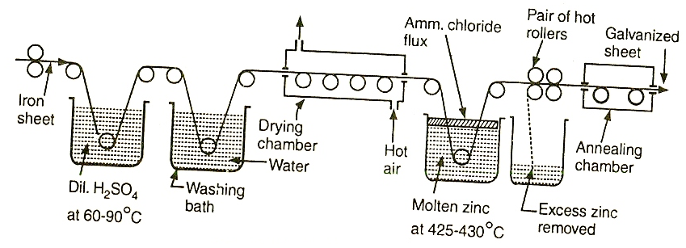
Application of zinc coating over iron surface to prevent rusting is called Galvanizing.
The iron or steel article like sheet, pipe, and wire is first cleaned by pickling with dilute sulphuric acid solution for 20 minutes at 90°C. This removes any scale, rust and impurities from the surface.
The article is then washed well and dried. It is then dipped in a bath of molten zinc maintained at 430°C. The bath surface is covered with ammonium chloride flux to prevent oxide formation. The coated article is passed through a pair of rollers to remove excess of molten zinc and to obtain a thin uniform coating. It is then annealed at 650°C and finally cooled slowly.
Application
Galvanizing is used for the protection of iron from atmospheric corrosion in the form of roofing sheets, wires, pipes, nails, bolts, screws, buckets, tubes, etc.
It may be noted that zinc dissolved in dilute acids to form highly poisonous compounds. Hence, galvanized utensils cannot be used for preparing and storing foodstuffs, especially acidic ones.

(b) Tinning (Jan 16, Nov 16)
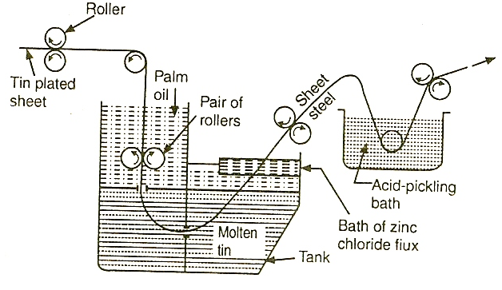
Application of tin over copper, brass, steel is called Tinning. In tinning, base metal is first treated with dil. H₂SO₄ to remove any surface impurities. It is then passed through a bath of zinc chloride flux. The flux helps molten metal to adhere to the metal sheet.
The metal sheet then passes through a tank of molten tin kept at 235°C and passed through surface of a layer of palm oil. Palm oil protects hot tin-coated surface from immediate oxidation. It is then passed through a pair of rollers to remove any excess of tin and produce a thin film of uniform thickness on steel sheet.
Application
Tin posses considerable resistance against atmospheric corrosion. It is used for coating steel, copper and brass sheets. Because of non-toxic nature, tin is used for manufacturing containers for storing foodstuffs, ghee, oils, kerosene and packing food materials. Tinned-copper sheets are used for making cooking utensils and refrigeration equipment.
13. Compare the process of galvanizing and tinning. (May 14, Jan 15, Jan 16)
Galvanizing | Tinning
(i) Process of covering iron or steel with a thin coat of Zinc metal.  (ii) Zinc protects base metal sacrificially.  (iii) Zinc continues to protect base metal by galvanic cell action, even if coating is broken at some places.  (iv) It cannot be used for storing acidic foodstuffs, since zinc reacts with acids forming poisonous compounds. | Process of covering steel with a thin coat of Tin metal.  Tin protects base metal due to its noble nature and higher corrosion resistance.  Tin protects base metal till coating is perfect. If any break occurs it causes rapid corrosion.  Tin coated containers can be used for storing any foodstuff, since tin with acid is non toxic.
14. Explain the corrosion control by metal cladding. (Sep 20)

Metal cladding is the process by which a dense layer of coating metal is bonded or sandwiched between two layers of coat metal and pressed between rollers. The choice of cladding material depends on corrosion-resistance required for particular environment.
Corrosion-resisting metals like nickel, copper, lead, silver, platinum, etc., and their alloys and stainless steel can be used as cladding material. The base metals are mild steel, aluminium, copper, nickel and their alloys.
Surface is to be plain and coat metal should be anodic to base metal. Generally, cladding is made by arranging thin sheets of coating metal and the base metal sheet in the form of a sandwich. They are then passed through rollers, under the action of heat and pressure.
Application: Metal cladding mainly used in aircraft industry as alclad sheeting, in which a plate of duralumin is sandwiched between two layers of 99.5% pure aluminium.
15. Discuss electroplating and its applications. (Jan 14, May 15, Jan 16, Nov 16, May 17 ,Dec 18, Dec 19,Sep20)
Electroplating consists in depositing a thin layer of superior metal or alloy over an inferior base metal by passing a direct current through an electrolytic solution, containing the metal ions to be deposited. The film so produced is quite uniform, with little/few pinholes per unit area and number of pinholes decreases as thickness of deposit increases.
Principle
Base metal to be plated is made as cathode of the cell and anode is either made of coating metal itself or an inert material of good electrical conductivity like graphite.
For copper plating, copper sulphate is used as electrolyte. The metal to be coated is made as cathode and copper electrode is made as anode. When electricity is passed from a direct current source, copper sulphate ionizes as,
CuSO₄ Cu²⁺ + SO₄^{2–} (ionization)
On passing current, Cu²⁺ ions go to cathode i.e., article to be plated and get deposited there.
Cu²⁺ + 2 e – Cu (at cathode)
The free sulphate ions migrate to the copper anode and dissolve an equivalent amount of copper to form sulphate.
Cu + SO₄ ^{2–} CuSO₄ + 2 e – (at anode)
Copper sulphate thus formed dissolves in electrolyte. Hence there is a continuous replenishment of copper metal during electrolysis and has to be replaced by fresh one. If anode is made of some inert material like graphite, electrolytic salt is added continuously in order to maintain proper metal ion concentration in the bath. The process of electroplating goes on non-stop, since anode is not consumed and its replacement is not required.
Process
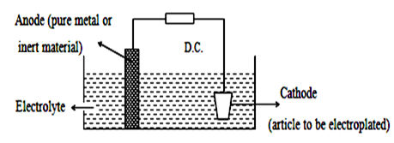
The article to be electroplated is first treated with organic solvent like acetone and carbon tetrachloride to remove oils, greases, etc. It is then treated with dilute acids to remove any scales, oxides, etc. For nickel and copper plating, HCl is used; while for chromium plating, H₂SO₄ is used.
The cleaned article is then made cathode of an electrolytic cell. Anode is either coating metal itself or an inert material like graphite. Electrolyte is a solution of a soluble salt of coating metal and is kept in an electroplating tank. The anode and cathode are dipped in the electrolytic solution.
When direct current is passed, coating metal ions migrate to cathode and get deposited there. Thus, a thin layer of coating metal is obtained on the article, made as cathode.
Electroplating depends on various factors such as nature of metal, concentration ratio of electrolyte, current density, temperature, time, pH of electrolytic bath, etc.
For brighter and sooth deposits, favourable factors such as low temperature, medium current and low metal ion concentration are used.
Application
(i) Gold, silver, copper, nickel, chromium, etc., are most widely used metals for
decorative plating. Base metal used are steel, zinc, copper, aluminium, etc.
(ii) Iron and steel are protected from corrosion by electroplating them with copper,
nickel, chromium, etc.
- It is applied to improve physical appearance, hardness, surface properties and
engineering effects.
16. Write briefly on anodizing. (May 11, May 13, May 14, Jan 15, May 16, Dec 19, SEP 20)
Oxidation of metal surfaces by electrolysis process is called anodizing. These coating are produced on non ferrous metals like aluminium, magnesium, zinc and their alloy by anodic oxidation process in which the base metal acts as anode. It consists of making the article to be treated as anode in an electrolytic bath of chromic acid or phosphoric acid or sulphuric acid and gradually raising the current for a particular time when the base metal surface is oxidized.
After anodizing, metal is immersed in hot water to decrease porosity of oxide film. Irregularly shaped articles are easily and completely anodized and this oxide layer forms very suitable basis for paints and varnishes. Anodizing is not suitable for metals like magnesium.
E.g. Anodizing of aluminium
This process consists of keeping base metal, aluminium as anode in 3% chromic acid at moderate temperature of 40°C.
Lead or stainless steel is used as cathode and a moderate current of 2 mA/cm² is passed for one hour.
On electrolysis, the oxide forms at aluminium surface as a result of progressive oxidation. The oxide film initially very thin, grows from metal surface outwards and increases in thickness as oxidation continues at aluminium anode. The outer part of oxide film formed is porous and this can be sealed by immersing in boiled water.
This treatment changes porous alumina into its monohydrate (Al₂O₃. H₂O) which occupies more volume and thereby the pores are sealed.
Application
(i) It gives thicker film and forms more protective coat.
(ii) It forms an insulating coat for electrically conducting aluminium.
(iii) It gives good resistance to corrosion and protects metals like Zn, Ni, Cr and tin.
(v) Air crafts parts, refrigerators pistons, reflectors, machine parts, etc., are anodized.

